March 21, 2017

Public Input Requested on Land Use Standards
For the Boothbay Village Area

About a year ago, Town Meeting adopted a new Comprehensive Plan for the town. The Comprehensive Plan laid out general directions for how the Town’s land use regulations should be revised. The Planning Board is now working to translate the concepts laid out in the Plan into new land use standards for the Town. Two key areas are the Boothbay Village Center area and the Village Fringe including the Country Club Road area. The two areas are shown on the section of the Future Land Use Plan included below. The Plan adopted at Town Meeting proposed significant changes in the land regulations for these two areas. The Planning Board is currently discussing possible new regulations for these areas and would like your input on the preliminary draft of the new regulations. The Planning Board will hold a public workshop on April 6, 2017 at the Old Town Hall starting at 6:30 PM. to listen to any feedback you have on the draft proposals. If you have questions, suggestions, or concerns please attend the workshop. If you cannot attend the workshop you can email your feedback to the Planning Board at townmanager@townofboothbay.org or drop off your comments with the Town Manager.

The following sections include excerpts from the adopted Comprehensive Plan that deals with these areas, a summary of the current land use standards for these areas, and excerpts from the first drafts of new land use regulations for these areas.

Comprehensive Plan Excerpts

The following sections dealing with Boothbay Village including the Country Club Road area are taken directly from the adopted Comprehensive Plan. The excerpt of the Future Land Use Plan that follows shows approximately where these areas are.

1. Boothbay Village Center Area
Vision -- The area around the Common and along Route 27 toward Boothbay Harbor continues to evolve as a true community center while enhancing its character as a New England village center. Traffic flow around the Common is improved and facilities for parking and pedestrians and bicyclists are upgraded making this more of a pedestrian area and linking the Common to adjacent residential areas. The Boothbay Village Center continues to be the public heart of the community and is increasingly used for community activities. Over time, the buildings in the Village Center are improved and limited new development occurs that reinforces the role of the Common Area as the community center.
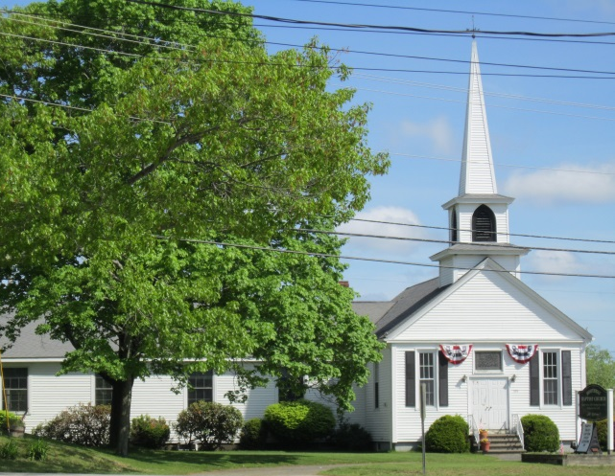
- Allowed Uses -- The standards for this area allow for a wide variety of residential uses in both existing buildings and in newly constructed buildings. Allowed residential uses would include uses such as single and two-family homes, townhouses, multifamily housing, and residential units in mixed use buildings such as a building with a commercial or office use on the first floor with apartments upstairs. Allowed nonresidential uses in this area would include uses that contribute to the desired pedestrian-focused, town center environment while excluding uses that generate large amounts of traffic especially truck traffic. Nonresidential uses that could be appropriate in this area include home occupations and home businesses, small-scale office, retail, and service uses , restaurants (without drive-through service), bed & breakfasts (B&Bs) and inns, and community uses such as municipal and government uses, daycare facilities, churches, and similar activities.

  - Development Standards – The following development standards are intended to be a guide for the development of appropriate ordinance provisions. The standards for the Boothbay Village Center Area are intended to encourage the area around the Common to continue to evolve as a true New England village center with a mix of uses in buildings focused on the Common and adjacent streets. The basic residential density requirement in the Boothbay Village Center Area would be 20,000-30,000 square feet of lot area per dwelling unit. If residential units are served by the public sewer system and year-round public water, the density of development would be increased possibly up to 6 to 8 units per acre. To encourage the development of a variety of housing in this area, small apartments with one bedroom would be counted as two-thirds of a dwelling unit for density purposes. The basic minimum lot size for nonresidential uses would be around 10,000 square feet with approximately 100 feet of road frontage.

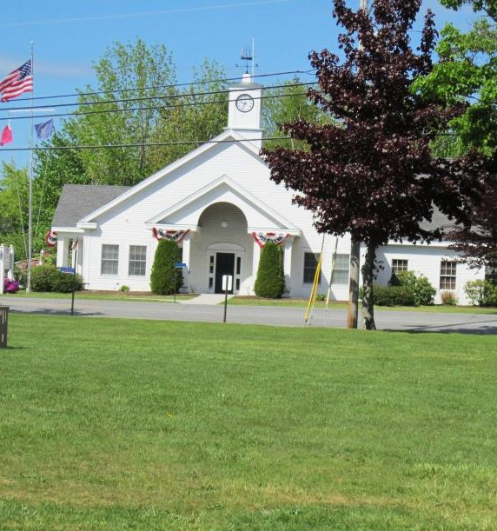
The development standards for the Boothbay Village Center area would require that all new development as well as substantial renovation or redevelopment of existing buildings be carried out in a manner that reinforces the New England village character of this area with buildings clustered around and oriented toward the Common. New buildings or substantial additions to existing buildings should be located reasonably close to the street. Buildings should be designed so that the main entrance is located and designed to promote pedestrian movement. The area between the front of the building and the street should be maintained as a lawn or landscaped area or as a pedestrian environment. Parking and service areas should be located to the side or rear of buildings.

2. Boothbay Village Fringe Area
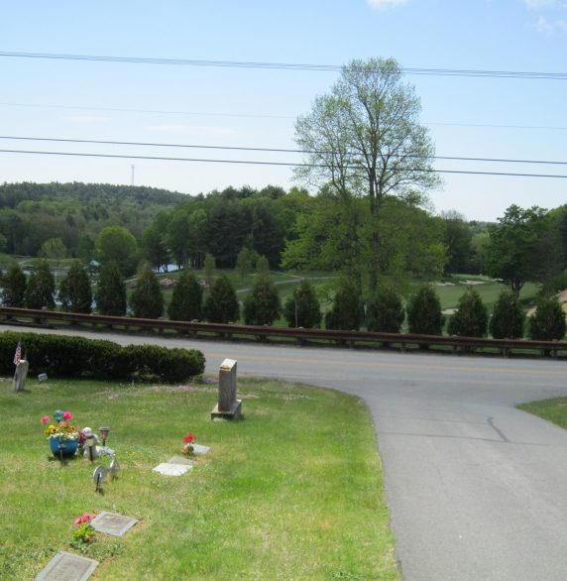
Vision -- Areas adjacent to the Common/Boothbay Village Center Area offer the potential for accommodating a variety of housing and compatible non-residential uses that can be served by the public sewer system and year-round public water. While there are constraints to development in this area, the private sector finds creative approaches for developing a limited amount of higher density housing and appropriate commercial uses that are served by public sewerage and year-round public water that is provided at the developer’s expense. The new residential areas have a pedestrian-friendly village character. To complement this development, the Town works to enhance pedestrian and bicycle facilities to link this new housing to the Boothbay Village Center.

  - Allowed Uses – The standards for this area allow a wide range of residential uses such as single and two-family homes, townhouses, multifamily housing, residential units in mixed use buildings and retirement/senior housing. New nonresidential uses in this area should be limited to uses such as home occupations and home businesses, small-scale office, service, and retail uses, restaurants, hotels and inns, golf courses/country clubs, meeting and convention facilities, low-intensity outdoor recreational uses, and community uses such as municipal and government facilities, daycare facilities, churches, and similar activities. Provisions should be included to allow the continuation and possible expansion of other legally existing businesses that would otherwise not be permitted in this area.

  - Development Standards – The following development standards are intended to be a guide for the development of appropriate ordinance provisions. The standards for the Boothbay Village Fringe Area are intended to create incentives for the development of higher-density, village-style residential uses that are served by public sewerage and year-round public water. The basic residential density requirement in the Village Fringe Area is 30,000-40,000 square feet of lot area per dwelling unit. If residential units are served by the public sewer system and year-round public water and are part of a planned development, the density of development would be increased to up to 8 to 10 units per acre. To encourage well planned development in this area, the development standards should discourage the creation of new lots along Country Club Road by providing incentives to develop on interior streets. To encourage the development of a variety of housing in this area, small apartments with one bedroom would be counted as two-thirds of a dwelling unit for density purposes. The basic minimum lot size for nonresidential uses would be around 20,000 square feet.

The development standards for the Boothbay Village Fringe Area should provide property owners and developers with flexibility in the design of new housing to permit development constraints to be accommodated in the layout of the project. As such, all subdivisions and other developments would be required to be designed in a manner that considers that opportunities and constraints of the site, that is harmonious with the natural environment, and that protects the water quality of Adams Pond. The development standards would also require that new housing be designed to create a neighborhood environment with appropriate pedestrian facilities to link the development to the Boothbay Village Center and community facilities.

Excerpt from the Future Land Use Plan

Overview of Existing Land Use Regulations

The following is a brief overview of the portions of the Town’s current Zoning Ordinance that apply to the areas designated as Boothbay Village Center and Village Fringe in the Comprehensive Plan. This overview is intended to provide a simplified summary of the current requirements. For specific information or answers to questions you should refer to the actual Zoning Ordinance and Zoning Map. A more complete comparison of the current requirements and the proposed requirements will be available on the Town’s website and at the April 6th workshop.

The area around the Common that is proposed to be included in the new Boothbay Village Center District is currently primarily located in the current Village District. The area that is proposed to be in the new Village Fringe District is primarily located in two current zones. The area on the south side of Country Club road is in the current General Residential District while the area on the north side is in the current C3 District.

Current Village District Requirements
- Allowed Residential Uses
  - One family dwelling
  - Two family dwelling (only in a conversion of an existing one family dwelling)
  - Multifamily dwelling (only in a conversion of an existing one family dwelling)
  - Lodging house
  - Accessory apartment
- Allowed Nonresidential Uses (examples of uses allowed – some require Planning Board approval)
  - B&B (only in existing residential dwelling)
  - Day care center
  - Home occupations
  - Laboratories
  - Neighborhood stores
  - Offices
  - Restaurant
  - Retail business
  - Service business
- Residential Density/Lot Sizes
  - Minimum lot size with public sewer and public water outside of Shoreland Zone – 20,000 SF
  - Minimum lot size other – 40,000 SF
  - Minimum lot size in Shoreland overlay – 60,000 SF
- Development Standards
  - Minimum lot width – 100 feet
  - Maximum height – 34 feet
  - Minimum road setback from ROW centerline – 33 feet
  - Front setback should harmonize with average setback of adjacent buildings
  - Minimum side and rear setback – 10 feet

Current General Residential District Requirements
- Allowed Residential Uses
  - One family dwelling
  - Two family dwelling
  - Multifamily dwelling
  - Lodging house
  - Accessory apartment
  - Retirement Facility
- Allowed Nonresidential Uses (examples of uses allowed – some require Planning Board approval)
  - B&B
  - Day care center
  - Home occupations
  - Hotels/motels
  - Neighborhood stores
  - Offices
  - Recreational Facility - Indoor & Outdoor
  - Restaurant
  - Retail business
  - Service business
- Residential Density/Lot Sizes
  - Minimum lot size outside of overlay – 40,000 SF
  - Minimum lot size other – 40,000 to 80,000 SF
- Development Standards
  - Minimum lot width – 100 feet or 150 feet in protection areas
  - Maximum height – 34 feet
  - Minimum road setback from ROW centerline – state road 50 feet or town road 33 feet
  - Minimum side and rear setback – 20 feet

Current C3 District Requirements
- Allowed Residential Uses
  - One family dwelling
  - Two family dwelling
  - Multifamily dwelling
  - Lodging house
  - Accessory apartment
  - Retirement Facility
- Allowed Nonresidential Uses (examples of uses allowed – some require Planning Board approval)
  - Agricultural packaging and storage
  - Agricultural product processing
  - Animal breeding
  - Auto vehicle sales & service
  - Auto repair
  - Auto service station
  - B&B
  - Campground
  - Car wash (sewered)
  - Conference/Convention Center
  - Day care center
  - Home occupations
  - Kennels
  - Laboratories
  - Manufacturing
  - Neighborhood stores
  - Offices
  - Recreational facilities – indoor & outdoor
  - Recycling operations
  - Restaurant
  - Retail business
  - Service business
  - Shopping center
  - Warehousing
  - Waste disposal facilities
  - Wholesale business
- Residential Density/Lot Sizes
  - Minimum lot size – 40,000 SF
- Development Standards
  - Minimum lot width – 100 feet
  - Maximum height – 34 feet or 44 feet along Country Club Road away from Route 27
  - Minimum road setback from ROW centerline – state road 50 feet or town road 33 feet
  - Minimum side and rear setback – 20 feet

Preliminary Draft of New Land Use Regulations

The Planning Board has started the process of translating the concepts set out in the Comprehensive Plan for these two land use designations into ordinance provisions that would govern new development after they are adopted by Town Meeting. The format the Planning Board is using for revising the ordinance is different from the current ordinance. The new format puts all of the allowed uses for all districts into a single table of allowed uses rather than having a separate list for each district. In the land use table, many uses are designated as Permitted with Review. The draft sets up a three level review process for these uses depending on the scale and complexity of a project. Simple projects would go straight to the CEO. Larger projects would go through a simplified Planning Board Review while very large projects would go through a more detailed Site Plan Review.

The following are excerpts from the preliminary drafts of the possible regulations for these two districts along with the Table of Allowed Uses. The columns that deal with the two districts are shaded. You can ignore the other columns. The Planning Board has already discussed some revisions to the drafts but before it makes any changes it is looking for feedback on the first draft. So please review the drafts, look at the Use Table, review what the Comprehensive Plan said about each area and tell us what you like, how the drafts could be improved, what you don’t like, and what questions you have.

7.5.3 Boothbay Village Center District (BVC)
NOTE: This is a preliminary draft that the Planning Board will be revising.

7.5.3.1 PURPOSE
The Boothbay Village Center District is intended to facilitate the evolution of the area around the Common and along Route 27 toward Boothbay Harbor into a true community center while enhancing its character as a New England village center. Traffic flow around the Common is improved and facilities for parking and pedestrians and bicyclists are upgraded making this more of a pedestrian area and linking the Common to adjacent residential areas. The Boothbay Village Center continues to be the public heart of the community and is increasingly used for community activities. Over time, the buildings in the Village Center are improved and limited new development occurs that reinforces the role of the Common Area as the community center.

7.5.3.2 ALLOWED USES
The uses allowed in the Boothbay Village Center (BVC) District are shown in the Table of Land Uses in Section 7.6. (See the separate table below) If the use is allowed in the district, the table also indicates if a review is required for the use. If review is required, the procedures and standards for each type of review are set out in Section 5.

7.5.3.3 SPACE AND BULK STANDARDS

7.5.3.3.1 | Minimum developable lot area | 20,000/6,000 SF – Residential  10,000 SF – Nonresidential
7.5.3.3.2 | Minimum net developable lot area per dwelling unit | 20,000 SF or  6,000 SF – Sewer and year-round public water
7.5.3.3.3 | Minimum lot width | 100 feet – Residential and Nonresidential  60 feet – Residential with sewer and year-round public water
7.5.3.3.4 | Minimum road setback | 10 feet from property line
7.5.3.3.5 | Maximum road setback | 25 feet from property line
7.5.3.3.6 | Minimum side property line setback | 10 feet
7.5.3.3.7 | Minimum rear property line setback | 20 feet
7.5.3.3.8 | Maximum building height | 45 feet
7.5.3.3.9 | Minimum building height | 2 usable stories or 24 feet
7.5.3.3.10 | Maximum impervious surface area | 60%

7.5.3.4 ZONE SPECIFIC DEVELOPMENT STANDARDS
Uses in the BVC District must conform to the following standards in addition to the Space and Bulk Standards:

7.5.3.4.1 Single-family homes that are served by public sewer and year-round public water may be located on lots with a minimum developable lot area of at least 6,000 square feet and a minimum of sixty (60) feet of road frontage.
7.5.3.4.2 Except for one-bedroom units with less than eight hundred (800) square feet of floor area, a dwelling unit in a two-family or multifamily dwelling or in a mixed-use building that is served by public sewer and year-round public water shall be allowed at a density of one dwelling unit per 6,000 square feet of net developable lot area. A dwelling unit with one bedroom in a two-family or multifamily dwelling or in a mixed use building that is served by public sewer and year-round public water shall be allowed at a density of one dwelling unit per 4,000 square feet of net developable lot area as long as the dwelling unit has less than eight hundred (800) square feet of floor area.
7.5.3.4.3 New buildings shall be located close to road. As part of the review of project, the Planning Board may allow a building to be located closer to the front property line if the distance from the edge of the paved travel way is more than twenty-five feet from the required front setback line.
7.5.3.4.4 Buildings must have a minimum of two usable stories unless the Planning Board finds that a multistory building is not appropriate for the proposed use. If the Planning Board allows a one story building, the building shall be designed so that the front façade facing the primary frontage appears to be a multistory building through the use of architectural features such as dormers, roof lines, or parapets.
7.5.3.4.5 New buildings and expansions of existing buildings that increase the gross floor area by more than fifty percent (50%) shall be designed in a manner that reinforces the New England village character of the district. This shall include consideration of roof forms, exterior materials, and the placement and size of doors and windows.
7.5.3.4.6 Buildings must be designed so that the main entrance is located and designed to promote pedestrian movement. If there is a sidewalk or other pedestrian way along the frontage of the lot, there must be a pedestrian connection between the sidewalk and the main entrance of the building.
7.5.3.4.7 The space between the road right-of-way and the front wall of the building must be maintained as a lawn or landscaped area or as a pedestrian environment. No vehicular or service facilities or areas shall be located in this area.
7.5.3.4.8 Parking and service areas must be located to the side or rear of the principal building. No parking shall be permitted in area in front of the front wall of the principal building for the full width of the lot.

7.5.4 Boothbay Village Fringe District (BVF)
NOTE: This is a preliminary draft that the Planning Board will be revising.

7.5.4.1 PURPOSE
The Boothbay Village Fringe District is intended to accommodate a variety of housing and compatible non-residential uses that can be served by the public sewer system and year-round public water. While there are constraints to development in this area, the district provides the private sector the opportunity to find creative approaches for developing a limited amount of higher density housing and appropriate commercial uses that are served by public sewerage and year-round public water that is provided at the developer’s expense. The new residential areas have a pedestrian-friendly village character. To complement this development, the Town works to enhance pedestrian and bicycle facilities to link this new housing to the Boothbay Village Center.

7.5.4.2 ALLOWED USES
The uses allowed in the Boothbay Village Fringe (BVF) District are shown in the Table of Land Uses in Section 7.6. (See the separate table below) If the use is allowed in the district, the table also indicates if a review is required for the use. If review is required, the procedures and standards for each type of review are set out in Section 5.

7.5.4.3 SPACE AND BULK STANDARDS

7.5.4.3.1 | Minimum developable lot area | 20,000/4,000 SF – Residential  10,000 SF – Nonresidential
7.5.4.3.2 | Minimum net developable lot area per dwelling unit | 20,000 SF or  4,000 SF – Sewer and year-round public water
7.5.4.3.3 | Minimum lot width | 100 feet – Residential and Nonresidential  60 feet – Residential with sewer and year-round public water
7.5.4.3.4 | Minimum road setback | State - 50 feet  Town – 33 feet  Private way – 8 feet from the closest edge of the R-O-W
7.5.4.3.5 | Maximum road setback | None
7.5.4.3.6 | Minimum side property line setback | 10 feet
7.5.4.3.7 | Minimum rear property line setback | 20 feet
7.5.4.3.8 | Maximum building height | 45 feet
7.5.4.3.9 | Minimum building height | None
7.5.4.3.10 | Maximum impervious surface area | 50%

7.5.4.4 ZONE SPECIFIC DEVELOPMENT STANDARDS
Uses in the BVF District must conform to the following standards in addition to the Space and Bulk Standards:

7.5.4.4.1 The creation of new residential lots fronting on Country Club Road is prohibited unless the Planning Board finds that the size, shape or physical characteristics of the site make this layout the most reasonable alternative. New residential lots should have their road frontage and vehicular access from interior roads when feasible.
7.5.4.4.2 Single-family homes that are served by public sewer and year-round public water may be located on lots with a minimum developable lot area of at least four thousand (4,000) square feet and a minimum of sixty (60) feet of road frontage.
7.5.4.4.3 Except for one-bedroom units with less than eight hundred (800) square feet of floor area, a dwelling unit in a two-family or multifamily dwelling or in a mixed-use building that is served by public sewer and year-round public water shall be allowed at a density of one dwelling unit per four thousand (4,000) square feet of net developable lot area. A dwelling unit with one bedroom in a two-family or multifamily dwelling or in a mixed use building that is served by public sewer and year-round public water shall be allowed at a density of one dwelling unit per two thousand five hundred (2,500) square feet of net developable lot area as long as the dwelling unit has less than eight hundred (800) square feet of floor area.
7.5.4.4.4 Residential subdivisions and developments with multiunit housing should be developed as planned developments in accordance with the provisions of _______.
7.5.4.4.5 Any new nonresidential use with frontage on Country Club Road must establish and maintain a vegetated buffer strip at least fifteen (15) feet in width along the Country Club Road frontage. The buffer strip shall meet the requirements of _______.

7.6 Table of Land Uses

The following table establishes the uses that are allowed in each zoning district. For each use, its status in a particular zone is indicated by one of the following designations:

- N means the use is not allowed in that zone
- Y means that the use is allowed and does not need a permit
- C means that the use is allowed and that it needs review and approval by the Code Enforcement Officer in accordance with Section 6
- PR means that the use is allowed and that it needs review and approval. Based on the criteria set out in Section 5 and the specifics of a project, the review could be Site Plan Review, Planning Board Review, or Code Enforcement Officer Review
- SD means that the use requires review and approval by the Planning Board under the standards for subdivisions
- MH means the use requires review and approval by the Planning Board under the standards for mobile home parks
- NA means not applicable

Legend

The column headings in the table identify the various land use districts using the following abbreviations:

- Mixed Use Districts
BVC Boothbay Village Center District
BVF Boothbay Village Fringe District

USE/ACTIVITY/  DISTRICT | R | R-C | BVC | BVF | BVMU | EBV | SG | RMU | CC | MB | MC | RP | WRP | WP
RURAL – RESOURCE - AGRICULTURAL USES
Agricultural Packaging and Storage |  |  | N | PR
Agricultural Product Processing |  |  | N | PR
Agriculture/Farming |  |  | Y | Y
Animal Breeding or Care |  |  | N | PR
Farm Stand |  |  | C | C
Aquaculture (Land support for) |  |  | N | PR
Commercial Fishing Activities |  |  | N | Y
Firewood Processing |  |  | N | N
Mineral Extraction |  |  | N | N
Timber Harvesting |  |  | N | C
RESIDENTIAL USES
Accessory Apartment |  |  | C | C
Congregate Housing/Assisted Living |  |  | PR | PR
Dwelling, Multifamily |  |  | PR | PR
Dwelling, One Family |  |  | C | C
Dwelling, Two Family |  |  | C | C
Dwelling, Townhouse |  |  | PR | PR
Dwelling Unit in a Mixed-Use Building |  |  | PR | PR
Housing for Seasonal Workers |  |  | PR | PR
Live-Work Unit |  |  | PR | PR
Lodging House |  |  | PR | PR
Mobile Home Park |  |  | N | N
Retirement Facility |  |  | PR | PR
Short Term Rental |  |  | PR | PR
Temporary Business Housing |  |  | N | N
COMMERCIAL USES
USE/ACTIVITY/  DISTRICT | R | R-C | BVC | BVF | BVMU | EBV | SG | RMU | CC | MB | MC | RP | WRP | WP
Amusement Park |  |  | N | N
Auto, Rec. Vehicle Sales & Service |  |  | N | N
Automobile Repair |  |  | N | N
Automobile Service Station |  |  | N | N
Bed & Breakfast |  |  | PR | PR
Bus Terminal |  |  | PR | N
Campground |  |  | N | N
Car Wash |  |  | N | N
Conference Center |  |  | PR | PR
Convention Center |  |  | N | PR
Day Care Center |  |  | C | C
Flea Market/Tent Sale |  |  | PR | N
Funeral Home |  |  | PR | PR
Gambling |  |  | N | N
Home Occupation |  |  | C | C
Home Business |  |  | PR | PR
Hotel/Motel |  |  | PR | PR
Indoor Theater |  |  | PR | PR
Junkyard |  |  | N | N
Kennel |  |  | N | N
Laboratory, Research Facility |  |  | PR | PR
Laundromat |  |  | PR | PR
Marina |  |  | N | N
Maritime Activities |  |  | N | N
USE/ACTIVITY/DISTRICT | R | R-C | BVC | BVF | BVMU | EBV | SG | RMU | CC | MB | MC | RP | WRP | WP
Medical Facilities |  |  | PR | PR
Miniature Golf |  |  | N | N
Neighborhood Store |  |  | PR | PR
Nursing Home – Assisted Living Facility |  |  | PR | PR
Offices; Business, Professional |  |  | PR | PR
Parking Facility |  |  | PR | PR
Recreational Facility - Indoor |  |  | PR | PR
Recreational Facility - Outdoor |  |  | PR | PR
Restaurant |  |  | PR | PR
Retail Business |  |  | PR | PR
Retail Fuel Distributor |  |  | N | N
Roadside Stand |  |  | C | C
Service Business |  |  | PR | PR
Sex Related Business |  |  | N | N
Shopping Center |  |  | N | N
Small Engine Repair & Sales |  |  | N | N
Storage Facility |  |  | N | N
Veterinary Hospital |  |  | N | PR
INDUSTRIAL – MANUFACTURING – DISTRIBUTION USES
USE/ACTIVITY/DISTRICT | R | R-C | BVC | BVF | BVMU | EBV | SG | RMU | CC | MB | MC | RP | WRP | WP
Communications Tower |  |  | N | PR
Manufacturing |  |  | N | N
Recycling Operations |  |  | N | N
Sawmill |  |  | N | N
Terminal for Bulk Oil and Gas |  |  | N | N
Trucking Distribution Terminal |  |  | N | N
Warehousing |  |  | N | N
Waste Disposal/Landfill |  |  | N | PR
Waste Transfer Facility |  |  | N | PR
Wholesale Business |  |  | N | N
Wood Processing |  |  | N | N
INSTITUTIONAL USES
USE/ACTIVITY/  DISTRICT | R | R-C | BVC | BVF | BVMU | EBV | SG | RMU | CC | MB | MC | RP | WRP | WP
Cemetery |  |  | Y | Y
Church, Parish House |  |  | PR | PR
Community Center, Club |  |  | PR | PR
Educational Facility |  |  | PR | PR
Hospital |  |  | PR | PR
Museum, Library |  |  | PR | PR
Parks and Recreation |  |  | Y | Y
Public Facility |  |  | PR | PR
MISCELLANEOUS – OTHER USES
Accessory Uses & Structures |  |  | Y | Y
Clearing of Vegetation |  |  | Y | Y
Dock - Temporary |  |  | N | N
Dock - Permanent |  |  | N | N
Earth Moving/Filling <50 cubic yards |  |  | C | C
Earth Moving/Filling >50 yards |  |  | PR | PR
Essential Services |  |  | Y | Y
Forest Management Activities |  |  | Y | Y
Mineral Exploration |  |  | Y | Y
Individual Private Campsite |  |  | N | N
Sign |  |  | C | C
USE/ACTIVITY  DISTRICT | R | R-C | BVC | BVF | BVMU | EBV | SG | RMU | CC | MB | MC | RP | WRP | WP
Wharf/Pier |  |  | N | N
Wind Turbines - Up to 60 feet in height |  |  | PR | PR
Wind Turbines - Over 60 feet in height |  |  | N | PR
Use similar to uses permitted with CEO Review |  |  | C | C
Use similar to uses permitted with review |  |  | PR | PR
Notes to the Table of Land Uses:
- Limited to a maximum of five hundred (500) square feet of floor area
- Only as an accessory to an allowed hotel/motel
- Allowed only if served by the public sewer system
- All storage shall occur completely inside of a building
- Limited to a maximum of one thousand (1000) square feet of floor area

